Extra Practical :- 3
AIM :- Develop a simple web application for a Sports Club to manage registrations for a Summer Camp. The application should allow administrators to efficiently handle the details of all campers (attendees) using CRUD (Create, Read,Update, Delete) operations.

INPUT Files :-

File - 1 :- { index.php }
<?php include 'db.php'; ?>
<h2>Add Camper</h2>
<form method="POST">
Name: <input type="text" name="name"><br><br> Email: <input type="email" name="email"><br><br> Sport: <input type="text" name="sport"><br><br>
<input type="submit" name="add" value="Add">
</form>

<?php
if (isset($_POST['add'])) {
$conn->query("INSERT INTO campers(name,email,sport) VALUES('{$_POST['name']}','{$_POST['email']}','{$_POST['sport']}')");
}
?>
<h2>Campers List</h2>
<table border="1">
<tr>
<th>ID</th><th>Name</th><th>Email</th><th>Sport</th><th>Action</th>
</tr>

<?php
$result = $conn->query("SELECT * FROM campers"); while ($row = $result->fetch_assoc()) {
echo "<tr>
<td>{$row['id']}</td>
<td>{$row['name']}</td>
<td>{$row['email']}</td>
<td>{$row['sport']}</td>

<td>
<a href='edit.php?id={$row['id']}'>Edit</a> |
<a href='delete.php?id={$row['id']}'>Delete</a>
</td>
</tr>";
}
?>
</table>

File - 2 :- { db.php }
<?php
$conn = new mysqli("localhost", "root", "", "sports_club");

if ($conn->connect_error) { die("Connection Failed");
}
?>

File - 3 :- { edit.php }
<?php include 'db.php';

$id = $_GET['id'];
$data = $conn->query("SELECT * FROM campers WHERE id=$id")->fetch_assoc();
?>
<form method="POST">
Name: <input type="text" name="name" value="<?= $data['name'] ?>"><br><br> Email: <input type="email" name="email" value="<?= $data['email'] ?>"><br><br> Sport: <input type="text" name="sport" value="<?= $data['sport'] ?>"><br><br>
<input type="submit" name="update" value="Update">
</form>
<?php
if (isset($_POST['update'])) {
$conn->query("UPDATE campers SET name='{$_POST['name']}',
email='{$_POST['email']}',
sport='{$_POST['sport']}' WHERE id=$id"); header("Location: index.php");
}
?>

File - 4 :- { delete.php }
<?php include 'db.php';

$id = $_GET['id'];
$conn->query("DELETE FROM campers WHERE id=$id");

header("Location: index.php");
?>

OUTPUT:-

Home page

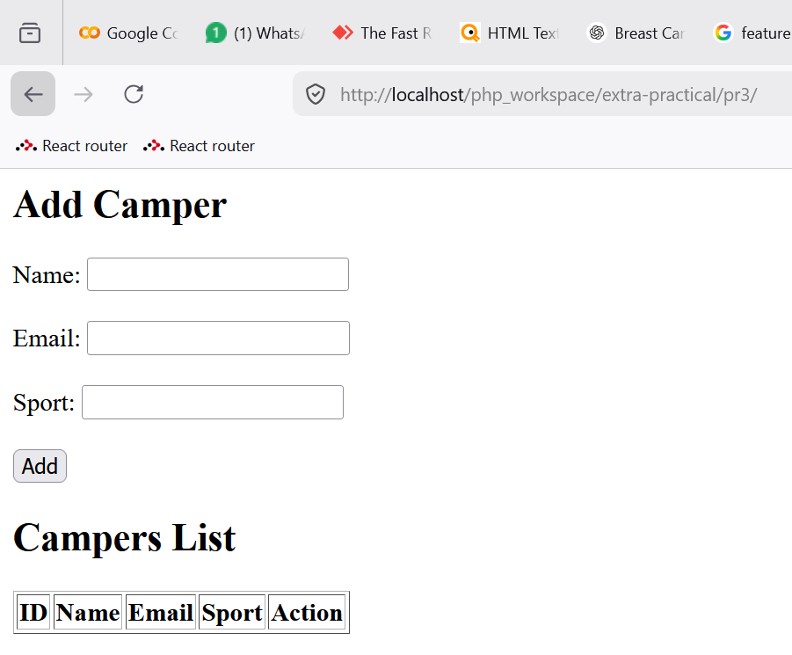

Add data at-least 5

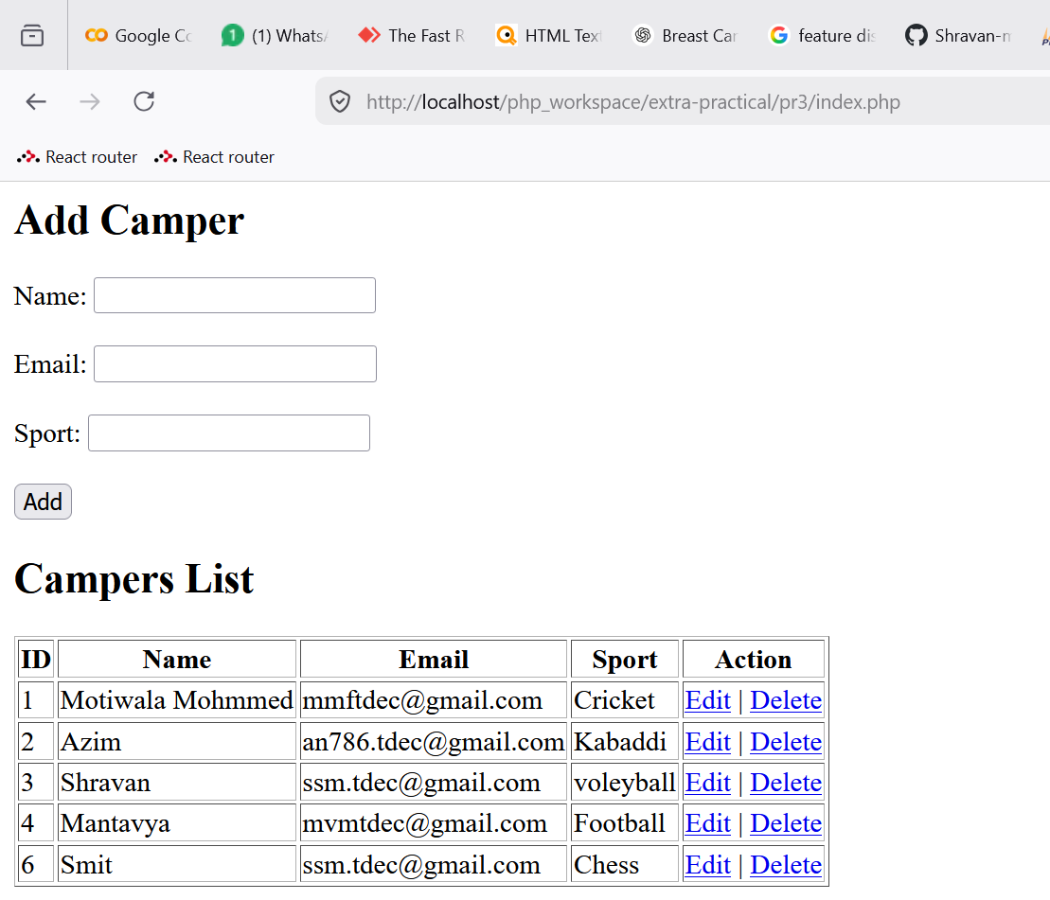

3 . update camper id1 sport - cricket to carroom

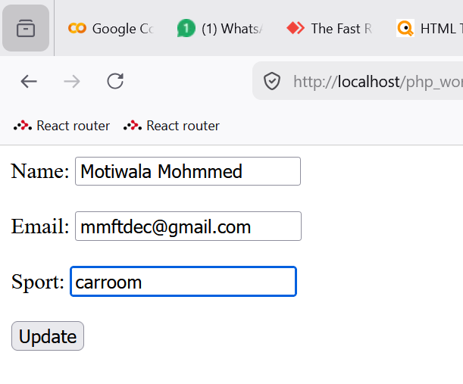

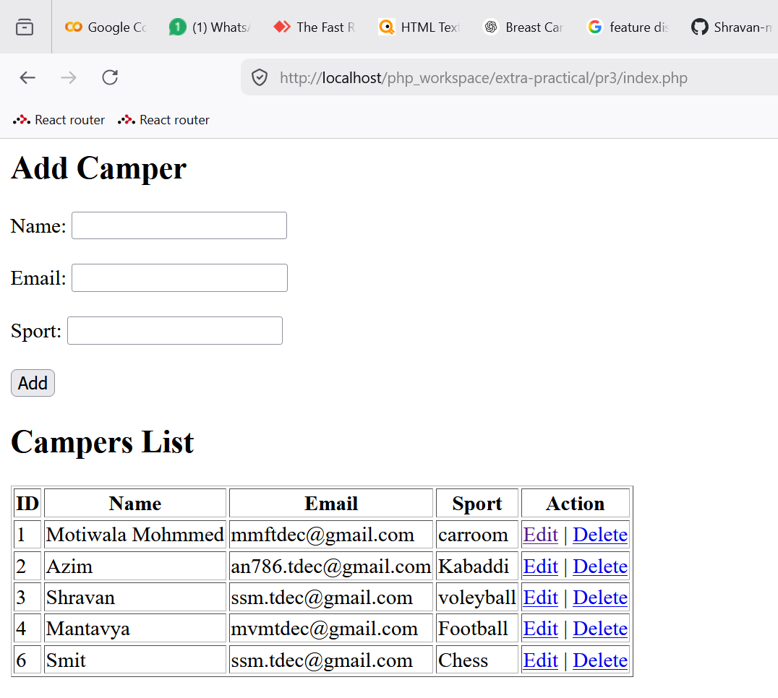

Delete the campers with id 1 and 3

